**Course code: CSE101**

**Course title: COMPUTER PROGRAMMING**

**FINAL SUBMISSION REPORT**

Real Estate

Advisor

GROUP PROJECT BY

|  |  |  |
| --- | --- | --- |
| S.No. | Registration no. | Name |
| 1. | 12200605 | Ishaan Khullar |

INDEX

|  |  |
| --- | --- |
| S.NO. | TOPICS |
| 1. | INTRODUCTION |
| 2. | DESCRIPTION OF THE MODULES |
| 3. | DATA FLOW DIAGRAM |
| 4. | PROGRAMMING CODE |
| 5. | OUTPUT SNAPSHOT |

# Introduction

The Real Estate Management System is a software application designed to manage the records of land and property. The system provides a user-friendly interface that helps users buy or sell properties without the need for extensive travel or manual searching. With the help of this system, users can easily search for properties based on specific criteria such as location, budget, number of bedrooms, etc. The system also provides the capability to apply for a loan if the user wishes to buy a property, with the option to choose the bank from where they want to take a loan. The software helps the user to check their loan eligibility and apply for the loan online. Additionally, the system allows users to manage their property records by adding, editing, or deleting them as necessary.

The Real Estate Management System provides a comprehensive end-to-end solution for property buyers and sellers. The system simplifies the buying and selling process by providing users with all the necessary tools and information in one place. This system can be beneficial for real estate agents, property managers, and individual buyers and sellers who want to streamline their processes and improve their efficiency.

Modules created

In order to increase the efficiency of the code we have divided the entire code into certain modules

1. Add New Record
2. Display the available property
3. Search
4. Buy/Sell
5. Edit/Delete Record
6. Apply Loans

# MODULES DESCRIPTION

1. Add new record-

**This module allows the user to add a new property record into the database. The user can enter the details of the property, such as its location, area, number of bedrooms, bathrooms, and other amenities. You can also include a feature to upload images of the property, which will help the user to visualize the property.**

1. Display the available property-

**This module displays all the available properties in the database. You can include filters, such as the location, price, type of property, and other criteria to help the user narrow down their search results**

3. Search**-**

**This module allows the user to search for properties based on specific criteria such as location, budget, number of bedrooms, etc. You can use advanced search algorithms to provide accurate and relevant search results.**

4.Buy/Sell-

**This module facilitates the buying and selling of properties. It allows the user to create a listing for their property and also to search for properties that they are interested in buying. You can include features such as payment gateways, secure transactions, and property ownership transfer**.

5. Edit/Delete Record-

**This module allows the user to edit or delete their property records from the database. The user can update the details of the property, such as its price, availability, and other information. They can also delete their property record if they have sold it or if it is no longer available.**

6. Apply Loans-

**This module helps the user to apply for a loan if they want to buy a property. The user can provide their details such as name, contact number, email address, and other necessary information.**

# DATA FLOW DIAGRAM

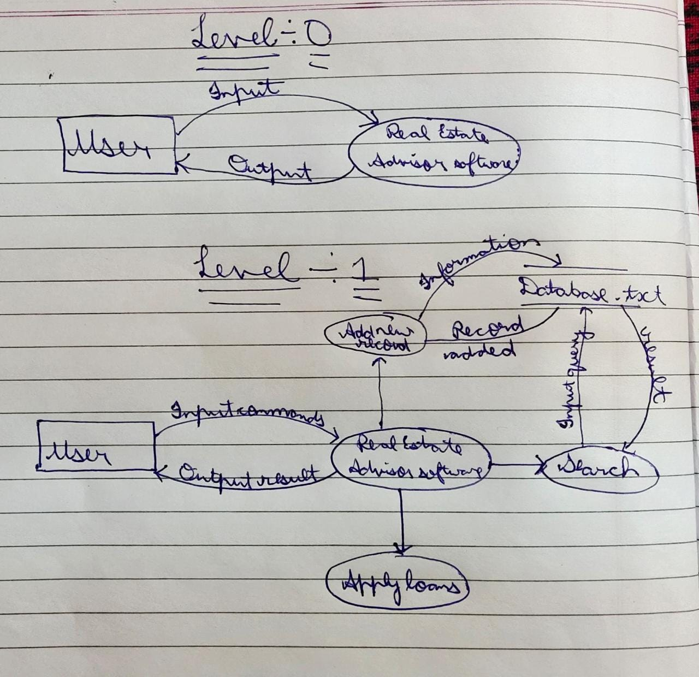

PROGRAMMING CODE

#include<stdio.h>

#include<string.h>

struct record{

    int id;

    char location[100];

    int cost;

    int area;

    int bhk;

}r;

void add_new_record(){

    int n;

    FILE *p;

    p=fopen("Database.txt","a");

    printf("Enter the Id of the property: ");

    scanf("%d",&r.id);

    printf("Enter the Location of the property: ");

    scanf("%s",r.location);

    printf("Enter the Cost of the property: ");

    scanf("%d",&r.cost);

    printf("Enter the Area of the property: ");

    scanf("%d",&r.area);

    printf("Enter the BHK of the property: ");

    scanf("%d",&r.bhk);

    fprintf(p,"%d %s %d %d %d\n",r.id,r.location,r.cost,r.area,r.bhk);

    fclose(p);

    printf("Record Added Successfully\n");

}

void display_the_property(){

    FILE *p;

    p=fopen("Database.txt","r");

    char c=fgetc(p);

    printf("\n");

    while(c != EOF){

        printf("%c",c);

        c=fgetc(p);

    }

    printf("\n");

}

void search(){

    FILE *p;

    p=fopen("Database.txt","r");

    char s[100];

    int found=0;

    printf("Enter location for the property: ");

    scanf("%s",s);

    while(fscanf(p,"%d %s %d %d %d\n",&r.id,r.location,&r.cost,&r.area,&r.bhk) != EOF){

        if(strcmp(s,r.location)==0){

            printf("%d ",r.id);

            printf("%s ",r.location);

            printf("%d ",r.cost);

            printf("%d ",r.area);

            printf("%d\n",r.bhk);

            found=1;

        }

    }

    fclose(p);

    if(found==0)

        printf("No propertty at %s found\n",s);

}

void buy_or_sell(){

    int property,n;

    printf("1. Buy\n");

    printf("2. Sell\n");

    scanf("%d",&n);

    if(n==1){

    printf("Enter Id of property to buy: ");

    scanf("%d",&property);

    FILE *fp = fopen("Database.txt", "r");

    FILE *temp = fopen("temp.txt", "w");

    int found = 0;

    while (fscanf(fp, "%d %s %d %d %d\n",&r.id,r.location,&r.cost,&r.area,&r.bhk) != EOF){

        if (property!=r.id) {

            fprintf(temp, "%d %s %d %d %d\n",r.id,r.location,r.cost,r.area,r.bhk);

        }

        else {

            found = 1;

        }

    }

    fclose(fp);

    fclose(temp);

    if (found==1) {

        remove("Database.txt");

        rename("temp.txt", "Database.txt");

        printf("\nProperty purchased successfully.\n");

    }

    else {

        remove("temp.txt");

        printf("\nRecord not found.\n");

    }

    }

    else if(n==2){

        FILE *p;

        p=fopen("Database.txt","a");

        printf("Enter Id of the property to be added: ");

        scanf("%d",&r.id);

        printf("Enter the location of the property to be added: ");

        scanf("%s",r.location);

        printf("Enter the cost of the property to be added: ");

        scanf("%d",&r.cost);

        printf("Enter the area of the property to be added: ");

        scanf("%d",&r.area);

        printf("Enter the BHK of the property to be added: ");

        scanf("%d",&r.bhk);

        fprintf(p,"%d %s %d %d %d\n",r.id,r.location,r.cost,r.area,r.bhk);

        fclose(p);

        printf("Record Added Successfully\n");

    }

}

void edit_or_delete_record(){

    int n;

    printf("1. Edit record\n");

    printf("2. Delete record\n");

    scanf("%d",&n);

    if(n==1){

        int address;

        printf("Enter the Id to Update: ");

        scanf("%d",&address);

        FILE *fp = fopen("Database.txt", "r");

        FILE *temp = fopen("temp.txt", "w");

        int found = 0;

        while (fscanf(fp,"%d %s %d %d %d\n",&r.id,r.location,&r.cost,&r.area,&r.bhk) != EOF){

            if (address==r.id) {

                printf("Enter the New Location of the property: ");

                scanf("%s",r.location);

                printf("Enter the New Cost of the property: ");

                scanf("%d",&r.cost);

                printf("Enter the New Area of the property: ");

                scanf("%d",&r.area);

                printf("Enter the New BHK of the property: ");

                scanf("%d",&r.bhk);

                fprintf(fp,"%d %s %d %d %d\n",r.id,r.location,r.cost,r.area,r.bhk);

                printf("Record Updated Successfully\n");

                found=1;

            }

                fprintf(temp,"%d %s %d %d %d\n",r.id,r.location,r.cost,r.area,r.bhk);

        }

        fclose(fp);

        fclose(temp);

        if (found) {

            remove("Database.txt");

            rename("temp.txt", "Database.txt");

            printf("\nRecord deleted successfully.\n");

        }

        else {

            remove("temp.txt");

            printf("\nRecord not found.\n");

        }

    }

    else if(n==2){

        int address;

        printf("Enter the Id to delete: ");

        scanf("%d",&address);

        FILE *fp = fopen("Database.txt", "r");

        FILE *temp = fopen("temp.txt", "w");

        int found = 0;

        while (fscanf(fp, "%d %s %d %d %d\n",&r.id,r.location,&r.cost,&r.area,&r.bhk) != EOF){

            if (address!=r.id) {

                fprintf(temp, "%d %s %d %d %d\n",r.id,r.location,r.cost,r.area,r.bhk);

            }

            else {

                found = 1;

            }

        }

        fclose(fp);

        fclose(temp);

        if (found==1) {

            remove("Database.txt");

            rename("temp.txt", "Database.txt");

            printf("\nRecord deleted successfully.\n");

        }

        else {

            remove("temp.txt");

            printf("\nRecord not found.\n");

        }

    }

}

void apply_loans(){

    printf("\t\tHere's the list of Banks for Loans\n");

    printf("    \tName\tRate of Interest\tContact\n");

    printf("1.  \tSBI\t\t7%\t\t628 045 899\n");

    printf("2.  \tPNB\t\t8%\t\t973 244 8360\n");

    printf("3.  \tAxis\t\t7.7%\t\t954 657 4560\n");

    printf("4.  \tHDFC\t\t9%\t\t887 451 4787\n");

    printf("5.  \tUjjivan\t\t11%\t\t789 478 4567\n");

    printf("6.  \tOBC\t\t6%\t\t784 444 5654\n");

    printf("7.  \tDCB\t\t12.1%\t\t998 741 2450\n");

    printf("\n");

}

int main(){

    int choice;

    printf("\t\t\tWelcome to the Modern World\n");

    printf("Please select the option\n");

    while(1){

    printf("1. Add New Record\n");

    printf("2. Display the Property\n");

    printf("3. Search\n");

    printf("4. Buy or Sell\n");

    printf("5. Edit or Delete Record\n");

    printf("6. Apply Loans\n");

    printf("7. Exit...\n");

    scanf("%d",&choice);

    if(choice==1)

        add_new_record();

    else if(choice==2)

        display_the_property();

    else if(choice==3)

        search();

    else if(choice==4)

        buy_or_sell();

    else if(choice==5)

        edit_or_delete_record();

    else if(choice==6)

        apply_loans();

    else if(choice==7){

        printf("Bye...");

        printf("Sayonara...");

        break;}

    else

        printf("Invalid Choice\n");

    }

}

# OUTPUT

